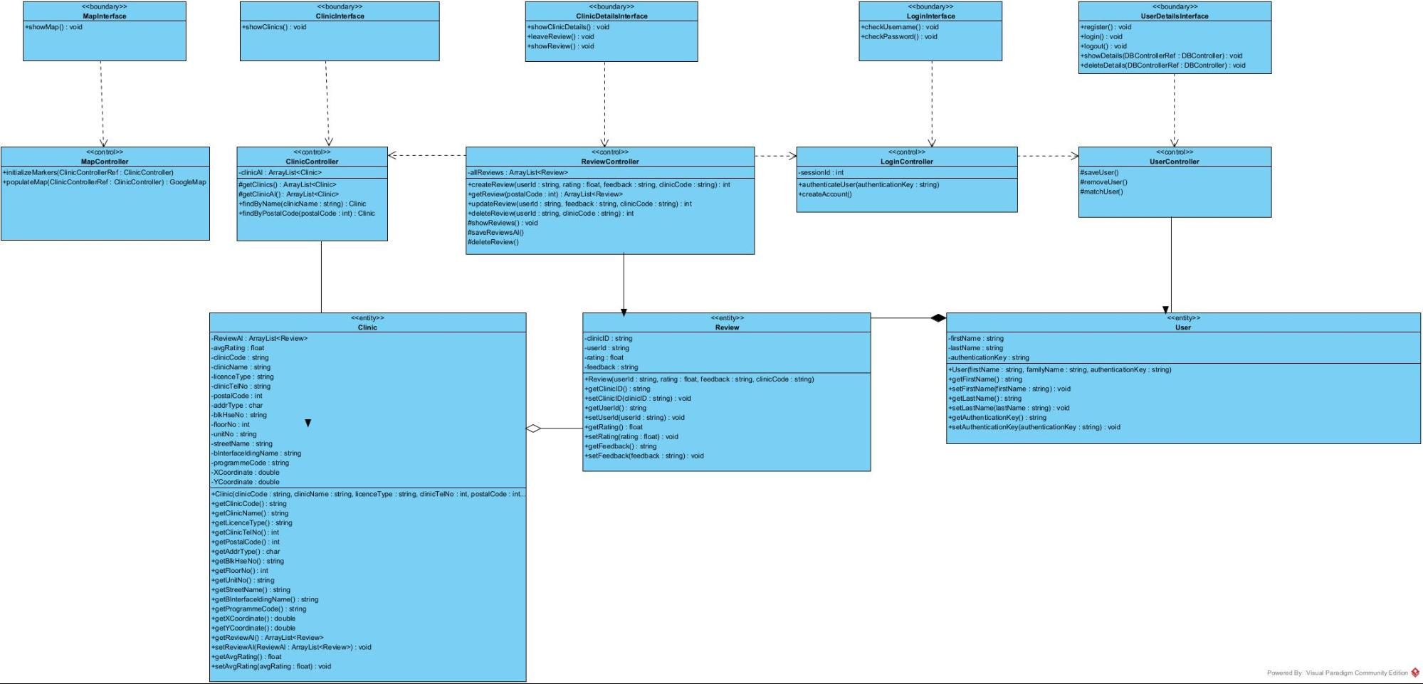

<<boundary>

**Mapinterface +showMap(): void**

**<<boundary>> Cliniclnterface**

<<boundary>>

**Clinic DetailsInterface +showClinic Details(): void +leaveReview(): void +showReview(): void**

<<boundary>>

**Login Interface +checkUsemame(): void +checkPassword(): void**

+showClinics(): void

<<boundary>>

**User Details Interface +register(): void +login() : void +logout(): void showDetails(DB ControllerRef: DBController): void deleteDetails(DBController Ref: DBController): void**

v

**<<control >> UserController**

<<control >>

**Map Controller initialize Markers(Clinic Controller Ref: Clinic Controller) populateMap(Clinic ControllerRef: ClinicController). Google Map**

<<control >>

**ClinicController - clinical : ArrayList<Clinic #getClinics(): ArrayList<Clinic #getClinical(): ArrayList<Clinic +findByName(clinicName : string): Clinic +findByPostal Code postalCode: int) : Clinic**

<<control>>

**ReviewController -all Reviews : ArrayList<Review *createReview(userld : string, rating: float, feedback : string, clinicCode :string): int *getReview(postal Code : int): ArrayList<Review +update Review(userld : string, feedback: string, clinic Code: string): int +deleteReview userld : string, clinicCode : string): int #showReviews(): void #saveReviews All #deleteReview()**

<<control >>

**Login Controller -sessionld: int +authenticateUser(authenticationKey: string) +create Account**

**#saveUser() #removeUser() #matchUser()**

<centity>>

Review -clinicID: string -userld: string -rating: float -feedback: string +Reviewuserld : string, rating: float, feedback:string, clinic Code: string) +getClinicID: string +setClinic ID(cliniciD:string): void +getUserld): string +setUserld/userld : string): void +getRating : float +setRating(rating: float) : void +getFeedback(): string +setFeedback(feedback :string): void

<<entity>>

User - firstName : string -lastName : string -authenticationKey: string *User(firstName : string, familyName : string, authenticationKey: string) +getFirstName(): string

setFirstName(firstName : string): void +getLastName(): string +setLastName(lastName: string): void +getAuthenticationKey(): string setAuthenticationKey(authenticationKey: string): void

<sentity>

Clinic -ReviewAl : ArrayList<Review> -avgRating : float -clinicCode : string -clinicName : string -licence Type: string -clinicTeiNo : string -postalCode: int -addr Type : char -blk HseNo: string -floorNo: int -unitNo : string -streetName : string -binterface ldingName : string -programmeCode: string -XCoordinate: double -YCoordinate: double +Clinic(clinicCode : string, clinicName : string, licence Type: string, clinicTelNo: int, postalCode: int... +getClinic Code(): string +getClinicName(): string +getLicence Type(): string +getClinic TelNo(): int +getPostalCode(): int +getAddrType(): char +getBlk Hse No(): string +getFloorNo(): int +getUnitNo(): string +getStreetName(): string +getBInterfaceldingName(): string +getProgrammeCode(): string +getxCoordinate(): double +gety Coordinate(): double +getReviewAl(): ArrayList<Review +setReviewA (ReviewAl : ArrayList<Review) : void +getAvg Rating(): float setAvg Rating(avgRating: float) : void

Powered By Visual Paradigm Community Edition